**Classification of Terrain From Satellite Imagery**

**A) Problem Statement**

**Definition:**

Satellite images have found wide applications in terrain classification as they generate high-resolution satellite images. Subsequently, the proposal will classify the terrain as the target source from the satellite imagery that can be used to detect various objects and can be proved useful for various applications.

**Challenges:**

Previously, various algorithms have been proposed by the researchers for terrain classification using satellite images, but they are engrossed with following challenges:

1. **Crop classification** and mapping is the most challenging task among the land use/land cover classification problems. At some extent it could be done if the diversity of crops is not very wide (for monocrop regions). Important precondition for successful classification are good enough training and validation data sets.
2. **Clouds** are the sword of Damocles for optical satellite data, especially for northern countries with rainy climate. It makes use of time series much more complicated. Even now, when Sentinel delivers images of each Earth location every 6 days, we cannot guarantee cloud-free image acquisition monthly. Especially difficult to get such imagery when they are needed most of all — in spring.
3. **Small scale benchmarks** (applications for restricted areas) and methods tested on tiny test sites (20 by 20 km) **are not scalable** in many cases. What works for small test site does not work for large scale area. If you do not work with big satellite data, you will not believe me. Trusted machine learning techniques, such as Bayes classifier, Maximum likelihood methods, kernel algorithms like Support Vector Machine, overperforming others for small test sites, do not work for large scale problems.

**Scope:**

Keeping in view the above, terrain classification with high accuracy rate and low processing time can be proved extremely applicable and serviceable. Following are the practical applications enlarging the scope of the project:

1. Geological or Geo-morphological features are enhanced in radar images because of oblique viewing of the sensor and to its ability to penetrate - to a certain extent - the vegetation cover.
2. In India, 40 million hectares of arable land is flood prone. Meteorological forecasting improvements need active sensors and greater receptivity. Hence, the data can be used for flood impact monitoring on an operational basis such as in Brahmaputra Plains.
3. Monsoon cloud cover during major crop growth season affects data collection and there by the capability for in-season crop forecasts. Crop yield forecasting models use the SAR data.

The proposed project will perform efficiently and effectively in extracting information from even low- resolution images.

**Background**

Many researchers have deployed various algorithms and proposed works based on Satellite imagery. Recent approaches include the statistically based automatic detection of marine oil slacks, detecting fluid paths in geothermal fields, Flood extent mapping from time-series SAR images based on texture analysis and data fusion, Evaluation of Multi-Frequency SAR Images for Tropical Land Cover Mapping, Terrain Classification based on Spatial Multi-attribute Graph using Polarimetric SAR Data, non-stationary speckle reduction in high resolution SAR images, urban impervious surface classification from SAR images, Target Recognition in SAR Images Based on Information-Decoupled Representation etc.

Hence, the previous works include quite old and obsolete tools and techniques which increase the computing time while lowering the accuracy rate.

Terrain

Classification

Terrain Classification Model

SAR

Imagery

**SAR Imagery Output**

Image

Segmentation

Terrain Classification Model Development

Information Extraction

SAR

Database

**Imagery Preprocessing**

**Imagery Preprocessing**

Figure 1: Architecture Diagram for Terrain Classification Model for Satellite Imagery

**Methodology**

Architecture of Terrain Classification Model from Satellite Imagery is shown in Figure 1.

Above architecture diagram incorporates 4 steps which show that how this project will be processed.

Step 1: Data collection and dataset preparation

This step will involve collection of Synthetic Aperture Radar (SAR) Images from various satellite sources and formatting them.

Step 2: Developing a CNN based Terrain Classification Model

Well-known pretrained CNN feature extraction models such VGG19, ResNet and terrain classification framework will be exploited for this task.

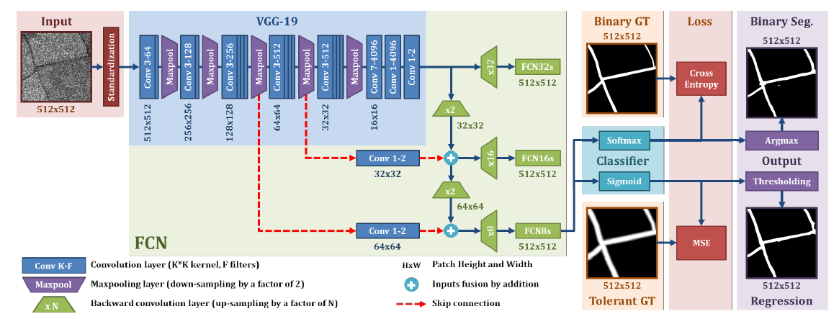

Figure 2: Henry, C., Azimi, S. M., & Merkle, N. (2018). Road Segmentation in SAR Satellite Images with Deep Fully-Convolutional Neural Networks. *arXiv preprint arXiv:1802.01445*.

Step 3: Image Segmentation and Training on Datasets

After extracting image local features such as SIFT or SURF features, segmentation will be performed to recognize terrain from SAR images. Then, Terrain Classification model will be trained using available datasets of SAR imagery.

Step 4: Deployment and Analysis

The trained and tested terrain classification model will be deployed in a real time scenario for further analysis.

**Experimental Design:**

**Dataset:**

The solution depends on the datasets obtained from data recorded by geostationary satellites and Indian Weather Satellites.

**Evaluation measures:**

Evaluation measures such as Accuracy and Mean Average Precision (MAP) will be computed by comparing the classified terrain satellite images with ground truth images from the datasets.

**Software and Hardware requirements:**

The following are likely used technologies for the proposed work to solve the problem:

1. OpenCV library which provides real-time computer vision and machine learning software library.
2. Python that is an efficient and debugging programming language.